Hardware Concepts

Input devices

Tablet
Tablet a tablet is a digitizer. In general, a digitizer is a device which is used to scan over an object and input a set of discrete coordinate positions.

These positions can then be joined with straight line segments to approximate the shape of the original object.

A tablet digitizes an object detecting the position of a movable stylus (a pencil shaped device) or a puck(a mouse like device with cross hairs for sighting positions) held in the user’s hand

A tablet is a flat surface and it’s size varies from 6 by 6 inches up to 48 by 72 inches or more

The accuracy of the tablets usually falls below 0.2 mm

There are three types of tablets
i. Electrical Tablet

A grid of wires on ¼ to ½ inch centers is embedded in the tablet surface

Electromagnetic signals generated by electrical pulses applied in sequence to the wires in the grid induce an electrical signal in a wire coil in the stylus or puck

The strength of the signal induced by each pulse is used to determine the position of the stylus.

The signal strength is also used to determine roughly how far the stylus is from the tablet

When the stylus is within ½ inch from the tablet it taken as near other wise it is either “far” or “touching”

When the stylus is near or touching, a cursor is usually shown on the display to provide visual feedback to the user

A signal is sent to the computer when the tip of the stylus is pressed against the tablet or when any button on the puck is pressed

The information provided by the tablet repeats 30 to 60 times per second

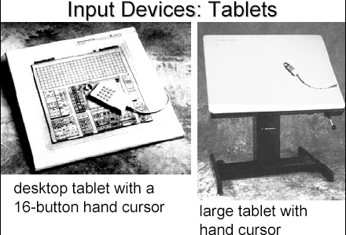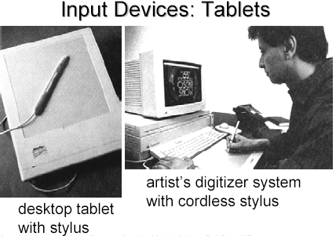

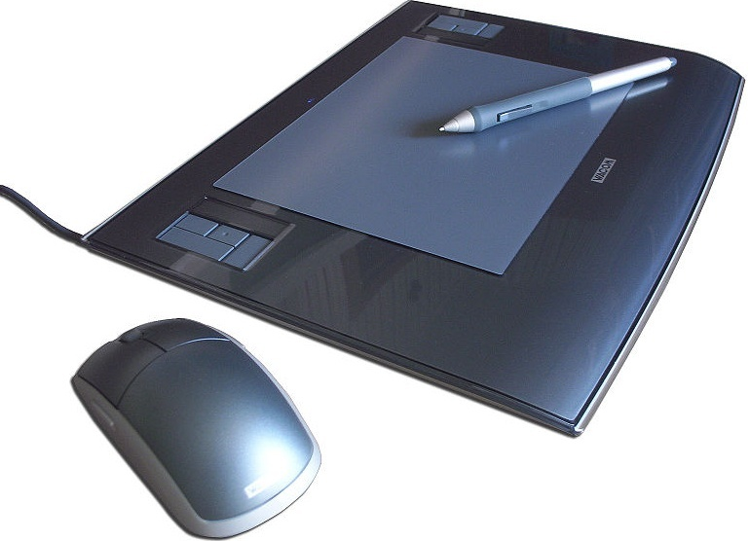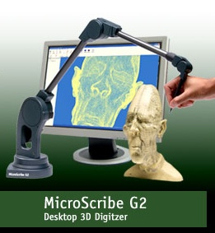

ii. Sonic Tablet
The sonic tablet uses sound waves to couple the stylus to microphones positioned on the periphery of the digitizing area

An electrical spark at the tip of the stylus creates sound bursts.

The position of the stylus or the coordinate values is calculated using the delay between when the spark occurs and when its sound arrives at each microphone

The main advantage of sonic tablet is that it doesn’t require a dedicated working area as the microphones can be places on any surface to form the tablet work area

This facilitates digitizing drawing on thick books because in an electrical tablet this is not convenient for the stylus can not get closer to the tablet surface

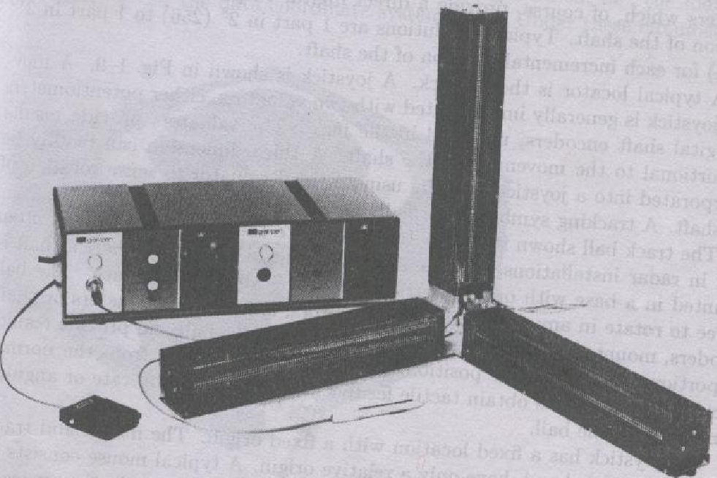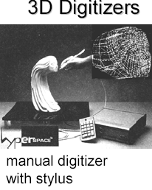

iii. Resistive Tablet
The tablet is just a piece of glass coated with a thin layer of conducting material

When a battery powered stylus is activated at certain position it emits high frequency radio signals which induces the radio signals on conducting layer.

The strength of the signal received at the edges of the tablet is used to calculate the position of the stylus

Several types of tablets are transparent, and thus can be backlit for digitizing x-ray films and photographic negatives.

The Resistive tablet can be used to digitize the objects on CRT because it can be curved to the shape of the CRT.

The mechanism used in the electrical or sonic tablets can also be used to digitize the 3D objects

Touch Panels

The touch panel allows the user to point at the screen directly with a finger to move the cursor around the screen or to select the icons.

i. Optical Touch Panel
It uses a series of infrared light emitting diodes (LED) along one vertical edge and along one horizontal edge of the panel

The opposite vertical and horizontal edges contain photo detectors to form a grid of invisible infrared light beams over the display area.

Touching the screen breaks one or two vertical and horizontal light beams thereby indicating the fingers position

The cursor is then moved to this position or the icon at this position is selected

This is a low resolution panel which offers 10 to 50 positions in each direction

ii. Sonic Touch Panel

Bursts of high frequency sound waves traveling alternately horizontally and vertically are generated at the edge of the panel .

Touching the screen causes part of each wave to be reflected back to its source

The screen position at the point of contact is then calculated using the time elapsed between when the wave is emitted and when it arrives back at the source

This is a high resolution touch panel having about 500 positions in each direction

iii. Electrical Touch Panel

It consists of slightly separated two transparent panel one coated with a thin layer of conducting material and the other with resistive material

When the panel is touched with a finger the two plates are forced to touch at the point of contact thereby creating the voltage drop across the resistive plate which is then used to calculate the coordinate of the touched position

The resolution of the touch panel is similar to that of sonic touch panel

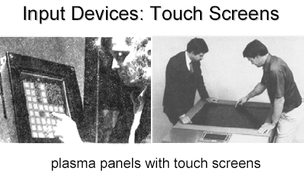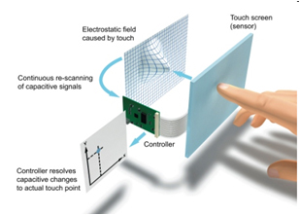

Light pen

It is a pencil shaped device to determine the coordinates of a point on the screen where it is activated such as pressing the button .

In raster display ‘y’ is set at y_{max} and ‘x’ changes from 0 to x_{max} the first scan line .

For the second line ‘y’ decreases by one and ‘x’ again changes from 0 to x_{max} and so on

When activated light pen sees a burst of light at certain position as the electron beam hits the phosphor coating at that position it generates an electric pulse

This is used to save the video controller’s ‘x’ and ‘y’ registers and interrupt the computer

By reading the saved valued the graphics package can determine the coordinates of the position seen by the light pen

Drawbacks
i. Light pen obscures the screen images as it is pointer to required spot

ii. Prolong use of it can cause arm fatigue

iii. It cannot report the coordinates of a point that is completely black as a remedy one can display a dark blue field in place of the regular image for a single frame time

iv. It gives sometimes false reading due to back ground lighting in a room

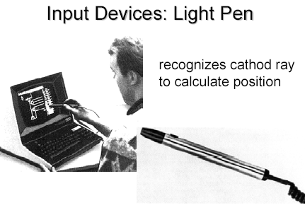
LCD (Liquid Crystal Display)
- A type of flat-panel display

- Uses liquid crystals between two sheets of material to present information on a screen

- An electric current passes through the liquid crystals, they twist

- Depending on how much they twist, some light waves are passed through while other light waves are blocked. This creates the variety of color that appears on the screen

- LCD monitors produce color using either passive-matrix or active-matrix technology

- Active-matrix display, also known as a TFT (thin-film transistor) display, uses a separate transistor to apply changes to each liquid crystal cell and thus display high-quality color that is viewable from all angles
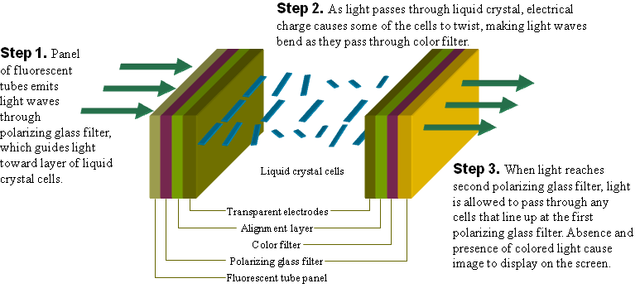

Plasma Panels (gas-discharge display)

- Region between two glass plates is filled with a mixture of gases such as neon, xenon.

- A series of vertical conducting ribbons is placed on one glass panel and a set of
horizontal ribbons is built into other gas panel.

- Firing voltages applied to a pair of horizontal and vertical conductors cause gas at
intersection of the two conductors to break down into a glowing plasma of electrons and
ions

- By controlling the amount of voltage applied at various points on grid, each point acts as a pixel(intersection of conductors) to display an image.

- Picture definition is stored in a refresh buffer and firing voltages are applied to refresh
pixel positions 60 times per second.
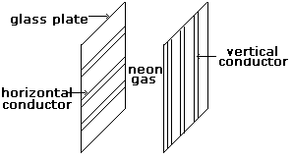
Voice System

- Consists of speech recognizer which analyze the sound of each person

- It must consist of dictionary of words ( frequency pattern) spoken words are converted
into frequency pattern.

Three Dimensional Viewing Devices

- A technique that reflects a CRT image from a vibrating, flexible mirror.

- As the varifocal mirror vibrates, it changes focal length.

- These vibrations are synchronized with the display of an object on a CRT so that each
point on the object is reflected from the mirror into a spatial position corresponding to
the distance of that point from a specified viewing position.

- This allows us to walk around an object or scene and view it from different sides.

Stereoscopic views

- Another method for representing three dimensional objects by overlapping images by
60%.

- Does not produce true 3D image but provides 3D effect by presenting a different view to
each eye of an observer so that scenes appears to have depth.

- Two views of a scene generated from a viewing direction corresponding to each eye.

- A component in virtual reality (a computer generated simulation of real or imagined
physical space, ultimate multimedia experience) systems.

Scanner
- Converts any printed image of an object into electronic form by shinning light onto the image and sensing the intensity of light’s reflection at any point.

- Color scanners use filters to separate components of color into primary additive colors (red, green, blue) at each point.

- R G B are primary additive colors because they can be combined to create any other color.

- Image scanners translate printed images into electronic format that can be stored into a computer memory.

- Software is then used to manipulate the scanned electronic image.

- Images are enhanced or manipulated by graphics programs like Adobe.

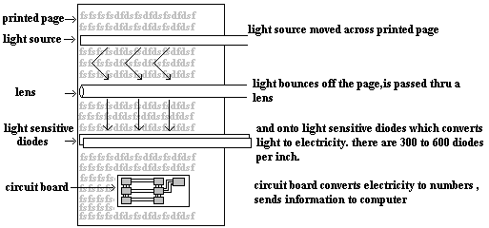

Optical Character Recognition (OCR)

- For text document we use Optical Character Recognition software to translate image into text that is editable.

- When a scanner first creates an image from a page the image is stored in computer’s memory as bitmap.

- A bitmap is a grid of dots, each dot represented by one or more bits.

- OCR software translates the array of dots into text that the computer can interpret as number and letters by looking at each character and trying to match the character with its own assumption about how the image should look like.


Hard Copy Devices
Printers
Printed output is referred to as hard copy and do not require electric power as they are printed on papers to read after printing and provide permanent readable form information

According to how they print printers can be of different types:
- Character printers prints one character of a text at a time
- Line printer prints one line of the text at a time
- A page printer prints one page of the text a t a time
According to the technology used printers produce output by either impact or non impact methods

Impact printers
Impact printers press the formed character faces against an inked ribbon onto paper
Character impact printers often have a dot matrix print head containing a rectangular array of protruding wire pins with a number of pins depending on the quality of the printer
Individual characters or graphics patterns are obtained by retracting certain pins so that the remaining pins form the pattern to be printed.

Non-Impact Printers
Non impact printers use laser techniques, ink-jet sprays etc to get images onto paper.

Ink-jet Devices
Ink-jet methods produce output by squirting ink in horizontal rows across a roll of paper wrapped on a drum.

When a heater is activated a drop of ink is exploded onto the paper

The print head contains an ink cartridge which is made up of a number of ink filled firing chambers each attached to a nozzle thinker that n a human hair

When an electric current is passed thru a resistor the resistor heats a thin layer of ink at the bottom of the chamber

Causing ink to boil and form a vapor bubble that expands and pushes ink thru the nozzle to form a droplet at the tip of the nozzle

The pressure of vapor bubble forces the droplet to move to the paper

A color ink jet printer employs four ink cartridges: one each for cyan, magenta, yellow and black

The ink of desired color can be placed at any desired point of the page in a single pass
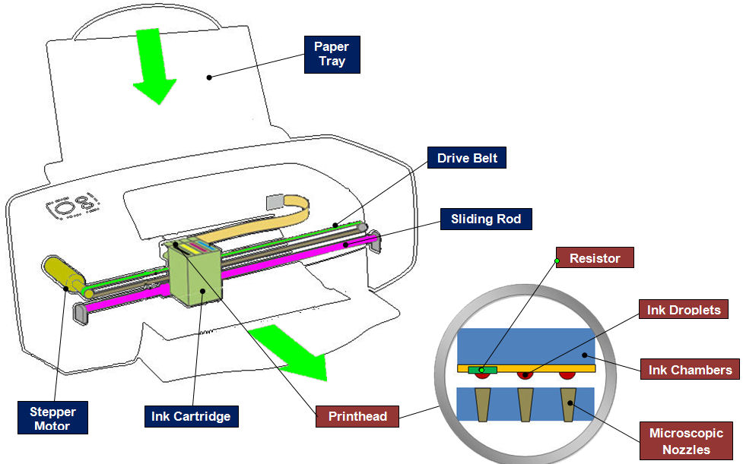
Laser Devices
These are page printers

They use laser beam to produce an image of the page containing text graphics on a photosensitive drum which is coated with negatively charge photo conductive material

In a laser device a laser beam creates a charge distribution on a rotating drum coated with a photo electric material such as selenium. Toner is applied to drum and then transferred to paper.
Just as the electron gun in a monitor can target any pixel, the laser in a laser printer can aim at any point on a drum, creating an electrical charge.

Toner, composed of tiny particles of oppositely charged ink, sticks to the drum in the places the laser has charged

With pressure and heat, the toner is transferred off the drum onto the paper.

The paper then moves to a fusing station where toner is permanently fused on the paper with page
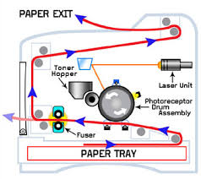
Potters
Plotter is a device that draws pictures on paper based on commands from a computer

They are used to produce precise and good quality graphics and drawing under computers control

They use motor driven ink pen or ink jet to draw graphic or drawings

Drawings can be prepared on paper, Velluym or Mylar (Polyester film)

Drum plotters
A drum plotter contains as long cylinder and a pen carriage

Paper is placed over the drum and the drum rotates back and forth to give up and down movement

The pen is mounted horizontally on the carriage that moves horizontally along with the carriage left to right or right to left on the paper to produce drawings

The pen and drum both mover under the computer control to produce the desired drawing

Several pens with different color dinks can be mounted on the carriage for multicolor drawing

Inkjet plotters
Many plotters us ink jets in place of ink pens

The paper is placed on a drum and the ink jets with different colored ink are mounted on a carriage

Such plotters are capable of producing multicolor large drawings

